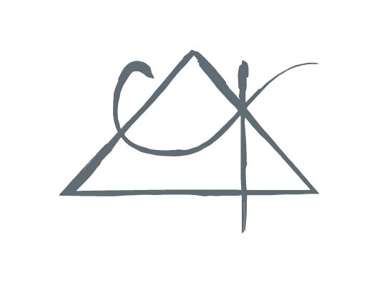
Central Alabama Psychology P. C.

Licensed Psychologist 1620 Carter Hill Road
Kale Kirkland, Ph.D. Montgomery, AL 36106
P:(334) 819-4870
AUTHORIZATION FOR DISCLOSURE OF INFORMATION

Patient Name: ______________________________ ___ Patient Date of Birth: _____________

I hereby authorize ________________________ to disclose to _________________________ the following information: ________________________________________________________
______________________________________________________________________________
for the purpose of ______________________________________________________________ .

I understand that this Authorization is voluntary. I understand that I may revoke this Authorization at any time by notifying Central Alabama Psychology P.C. in writing, but that doing so will not cancel any actions already taken in reliance on this Authorization. I understand that the duration of this consent will be no longer than would be necessary and reasonable to carry out the purpose for which it is given. Unless you wish to cancel this consent at an earlier time, it will automatically stop upon the date and/or event indicated:

Date/Event/Condition: __________________________________________________________ .

_________________________________________ ________________________
Signature of patient Date

_________________________________________ ________________________
Signature of parent/guardian/authorized person Date

__________________________________________ ________________________
Witness Signature Date

Note to party receiving information: This information has been disclosed to you from records whose confidentiality is protected by federal law which prohibits you from making any further disclosure of information without the specific written consent of the person to whom it pertains, or as otherwise permitted by such regulations. A general authorization for the release of medical or other information is not sufficient for this purpose. (This form meets the requirements of Federal Regulation 42CFR, Part 2.)

