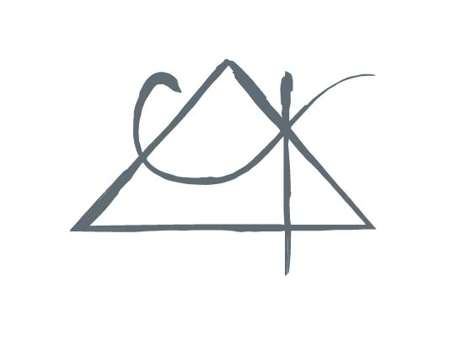
Central Alabama Psychology P. C.

Licensed Psychologist 1620 Carter Hill Road
Kale Kirkland, Ph.D. Montgomery, AL 36106
P:(334) 819-4870
GOOD FAITH ESTIMATE

NAME_____________________________
You have been referred to my office for treatment. I’m required by the 2022 No Surprises Act to give you a Good Faith Estimate of the cost of treatment if you are uninsured, or don’t want to use insurance for this care. The information provided is based upon fee for service (out of pocket) rates.
If you DO intend to use insurance, check with your insurance carrier to find out about your co-payment. We charge full fee at the time of service and will provide you with invoices and insurance claim forms so we may help you get filed. You will then be reimbursed by your insurance carrier.

Since I have not yet evaluated your symptoms, I must at this point estimate you course of treatment based upon the national average for a course of psychotherapy, which is 18 encounters.

This initial estimate is valid for 12 months, but you are entitled to receive an estimate at any upon request.
Current ICD-10 diagnosis: R69 (diagnosis deferred)

Anticipated Treatment:
- 1 session of CPT 90791 (diagnostic eval) at $200
- 17 weekly sessions of CPT 90837 at $175 per session
- Total= $3,175.00
This is a rough estimate based upon national averages. The duration of our work together can be longer or shorter depending upon your symptoms, your work between sessions, and your response to treatment.

Unless required by a court order (an extremely rare situation) you are free to discontinue treatment at any time, and free to discuss any other modifications to treatment modalities, frequency, or duration. You are ultimately in control of your own healthcare; I am here to provide help at your request.
Location: 1620 Carter Hill Road
Provider: Kale Kirkland, Ph.D.
NPI#: 1245486398
Fed Tax ID: 47-4310052

This information is not legal advice.

